- Which of the following diagrams best depicts the relationship between Dogs, Pets and Cats?
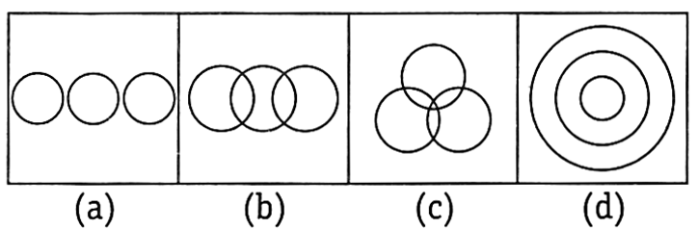
- Which of the following diagrams best depicts the relationship between Married, Women and Teachers?
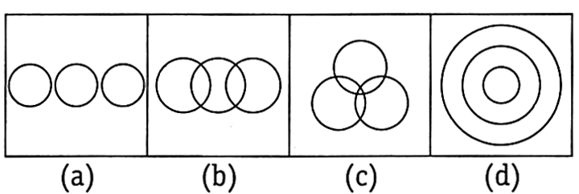
- Which of the following diagrams best depicts the relationship between Doctors, Human beings and Cats?
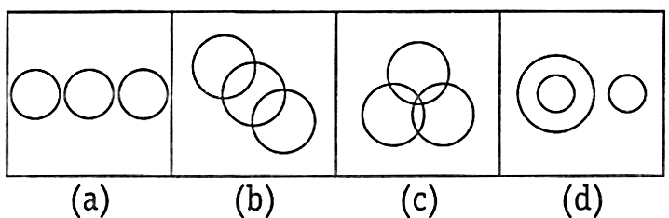
- Which of the following diagram best depicts the relationship between Females, Mother and Sisters?
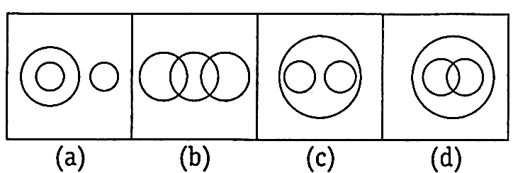
- Which of the following diagrams best depicts the relationship between Males, Husbands and Doctors?
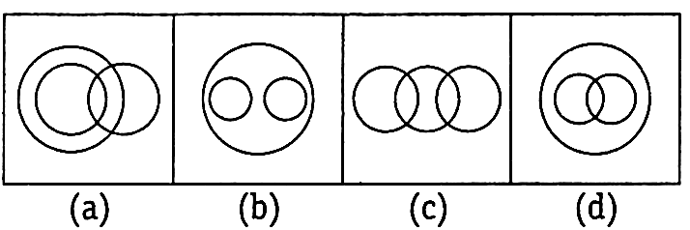
- Which of the following diagrams best depicts the relationship between professor, Author and Infants?
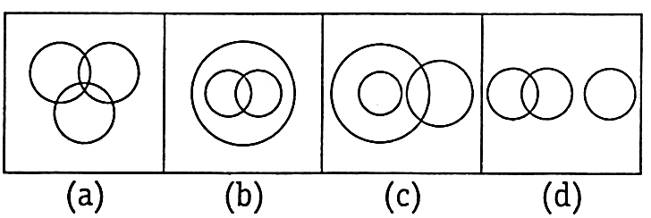
Directions (Q.7 – 16): Each of the questions given below contains three items. These items may or may not have some relation with one another. Each group of the items may fit into one of the diagrams (a), (b), (c), (d) and (e). You have to indicate that the group of items in each of these questions correctly fits into which of the diagram.
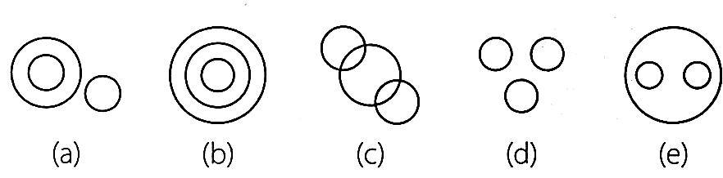
- Universe, Earth, Europe
- Picture, TV, Radio
- Living beings, Animals, men
- Radio, TV, Cinema hall
- Residence, Resident, Road
- Copy, Stationery, Car
- Coal mines, Factory, Field
- Clothes, Saree, Dhoti
- Chapter, Book, Topic
- Boys, Class, Girls
- The diagram given below represents owner, broker and worker. Identify the region which represents all the three i.e. owner, broker and worker.
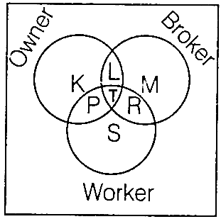
a) L b) T c) P d) R
- Which one of the following figures represents the relationship among brinjal, meat, vegetables?
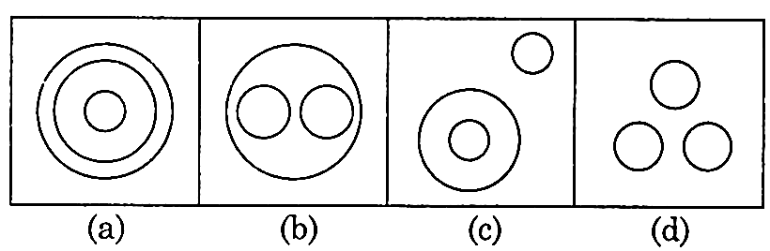
- Which of the following diagrams represents the relationship between Men, Women and Teachers?
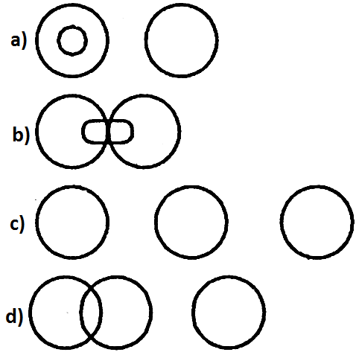
- Triangle represents singers. Rectangle represents Dancers. Circle represents Musicians. Square represents Instrumentalists. Name the portion which excludes singers.
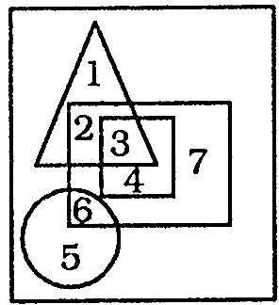
a) 1256 b) 4567
c) 1234 d) 2347
Directions (21): Each of these question below contains three groups of things. You are to choose from the following four diagrams, the one that depicts the correct relationship among the three groups of things is each question.
- Carrot, Food, Vegetable
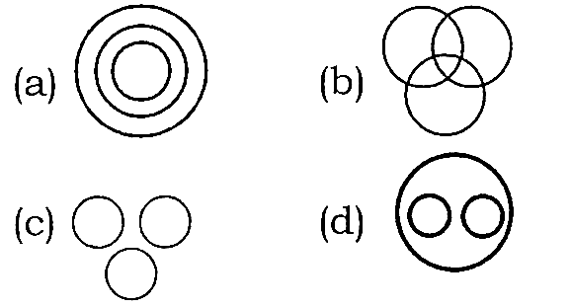
Direction (Q.22): Each of these questions below contains three groups of things. You are to choose from the following four lettered diagrams, the one that depicts the correct relationship among the groups of things in each question.
- Human beings, Teachers, Graduates
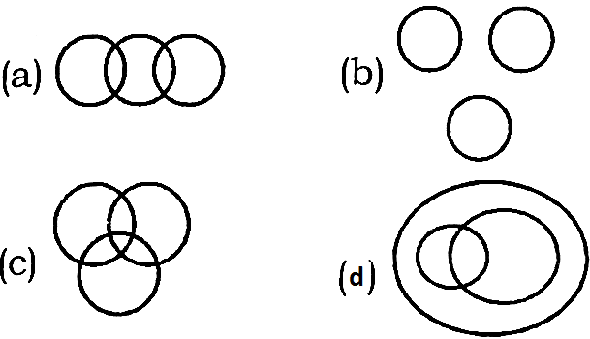
- Which one of the following diagrams best depicts the relationship among Fishes, Snakes and Birds?
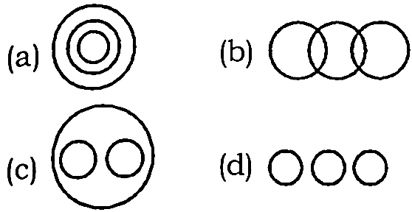
Direction (Q.24): In the following question, Identify the diagram that represents the best relationship among classes given below:
- Children, Serious, Naughty
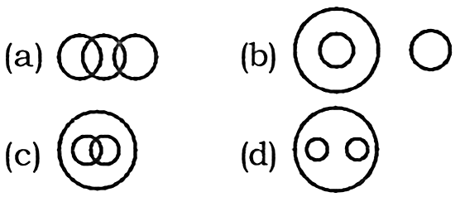
Direction (Q.25 – 26): In the following question, answer are based on the diagram given below, where the triangle represents doctors, the circle represents players and the rectangle represents the artists.
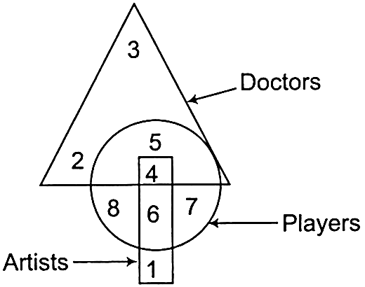
- Which numbered space in the diagram represents artists, who are neither players nor doctors?
a) 1 b) 2 c) 3 d) 4
- Which numbered space in the diagram represents players, who are neither artists nor doctors?
a) 1, 2 b) 3, 4 c) 6, 7 d) 7, 8
- Identify the diagram that best represents the relationship among classes given below:
Food, Curd, Spoons
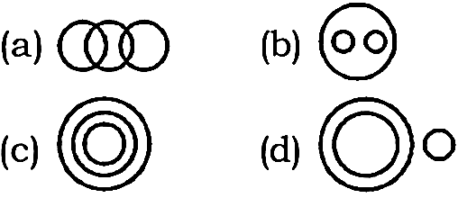
- Which one of the following diagrams represents the correct relationship among Society,
Teacher and Student?
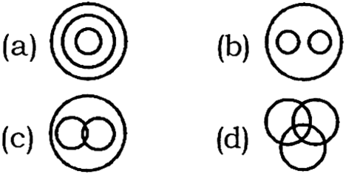
Direction (Q.29): In the following questions, three classes are given. Out of the four figures that follow, you are to indicate which figure will best represent the relationship amongst the three classes.(Elephants, Wolves, Animals)

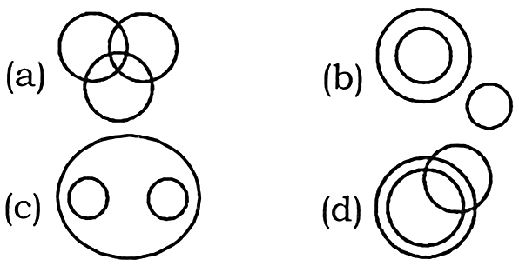
Direction (Q.30): In the following question below is based on the information given below. Four different sections have been projected with the help of four different figures. Rectangle represents female members, circle represents employees, triangle represents businessman and big triangle represents post graduates. Based on this information, answer the questions given below.
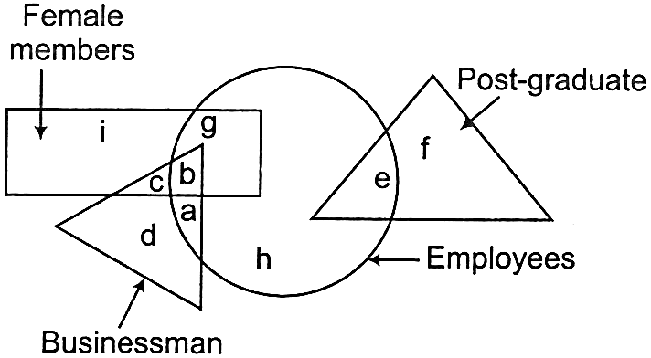
- Which of the following group of employees represents those employees, who are not businessman?
a) e, g, h b) a, g, h
c) b, g, e d) a, e, g, h
- Read the following diagram and find the region representing persons who are educated and employed but not confirmed.
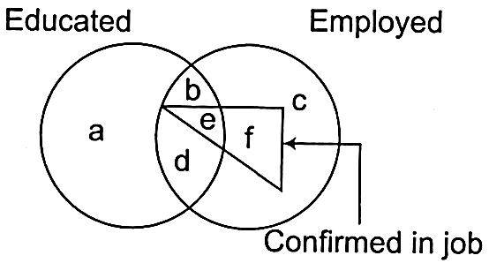
a) ac b) abc c) bd d) adc
- Some of the cricket players are tennis players, some tennis players are hockey players, no cricket player is a hockey player.
Which of the following diagrams correctly represents the above statements?
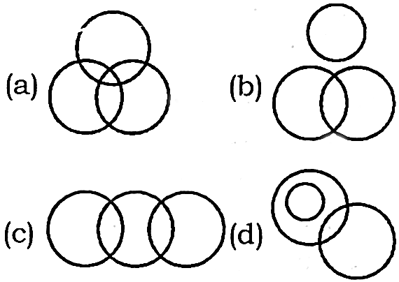
Direction (Q.33): In the following question given below contains three groups of items. You are required to choose one of the four numbered diagrams a), b), c) and d) that depicts the correct relationship among the three groups of items in the question.
- House, Bedroom, Kitchen.
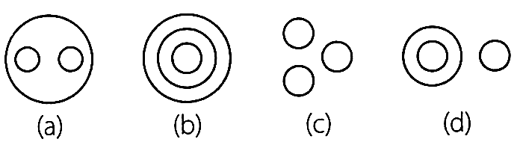
- The figure that best represents inter-relationship among “Star, Moon and Mars”.
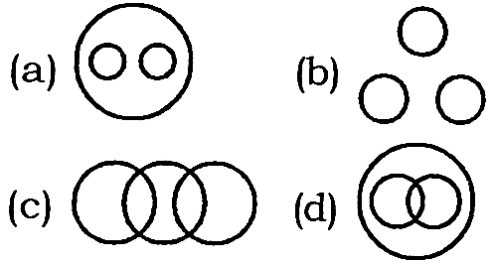
- Which one of the following diagrams best depicts the relationship among UNIVERSE, SUN & STAR?
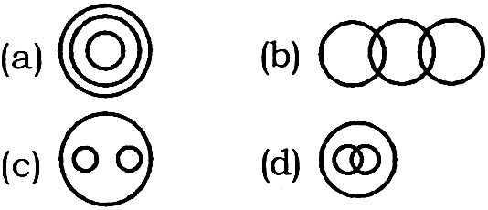
Direction (Q.36): In these question below contains three groups of things. You are to choose from the following diagrams, the one that depicts the correct relationship among the group of things in the question. (Tennis fans, Cricket Players, Students)

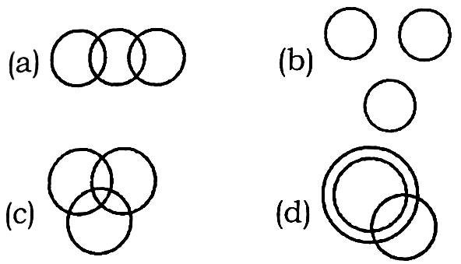
- Which diagram correctly represents the relationship between Politicians, Poets and Women?
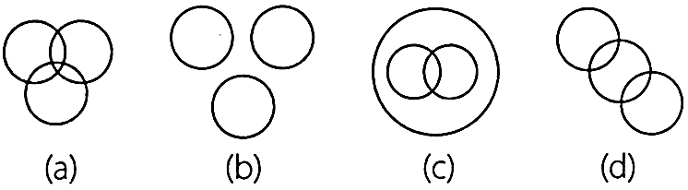
- Which of the following Venn Diagram gives the relationship between Friend, Guide and Philosopher?
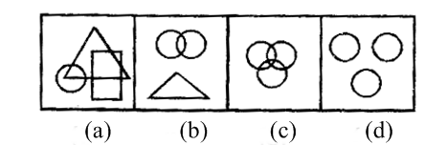
Directions (Q.39): Choose the Venn diagram which best illustrates the three given classes in each of the following questions:
- Protons, Electrons, Atoms
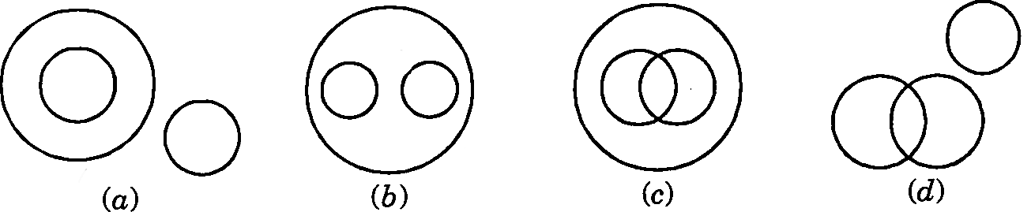
- Which one of the following diagrams best depicts the relationship among Cement, Bricks and Building materials?
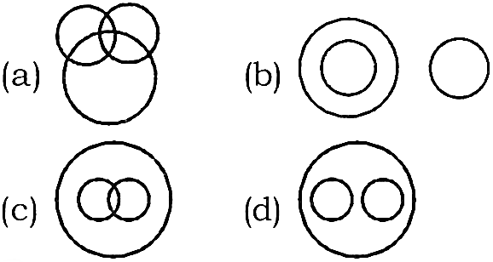
- Which one of the following diagrams represents the correct relationship among Lion, Fox and Carnivorous
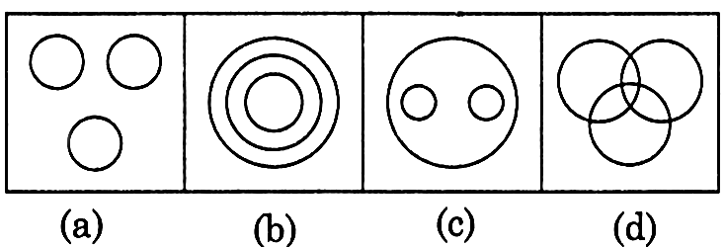
- Which of the following diagrams best depicts the relationship between Android, Smart Phone Visiting Cards?
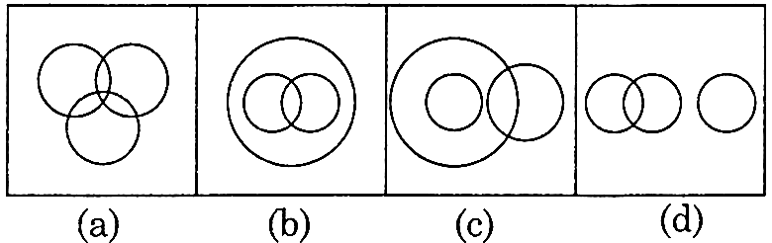

Directions (Q.43): Each of the given questions contain three or more elements. Select the Venn diagram which shows the relation between them.
- Fish, Meat, Fruits, Breakfast
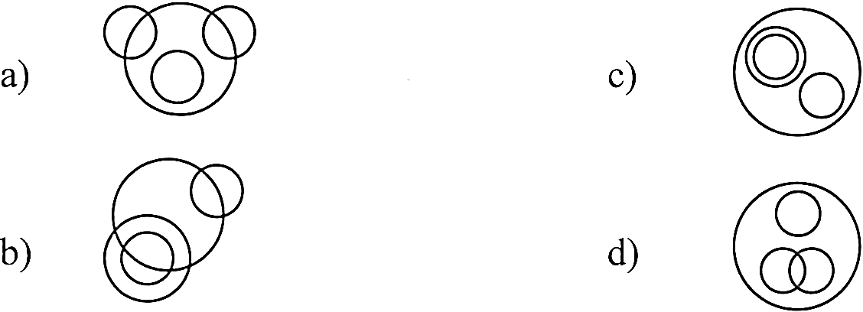
Directions (Q.44): Each of the given questions, contain three or more elements. Select the Venn diagram which shows the relation between them.
- Boat, Water, River.
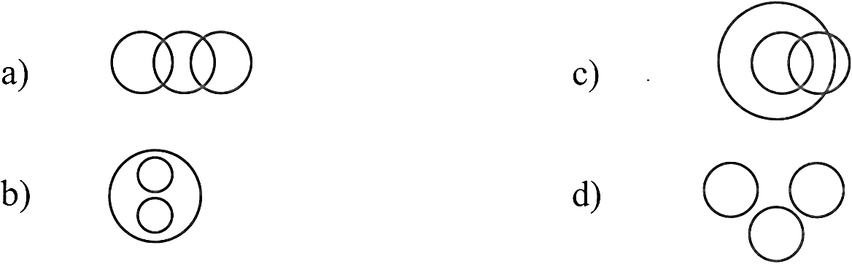
- Select one diagram from four a, b, c and d diagram. The diagram can express the best relation among three classes.
Minutes, Days, Months
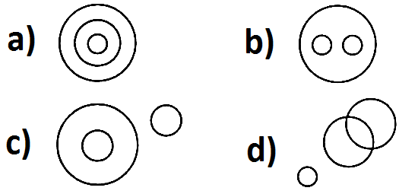
- Given below are three figures that represent graduates, post-graduates, officers. Which part represents all the officers who are graduates and post – graduates?
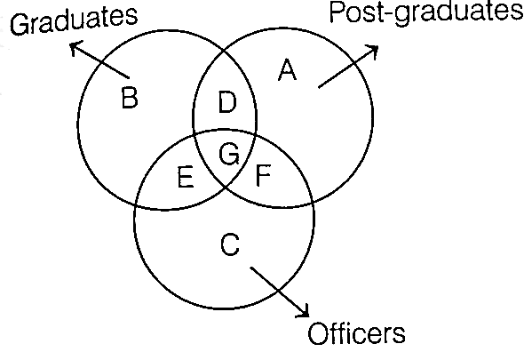
a) G b) D c) B d) C
- Which Venn diagram truly represents Teachers, Scholars and Students?
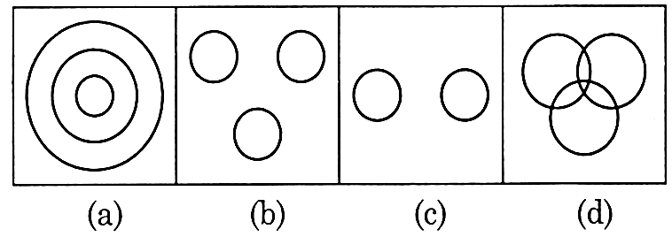
- Select the figure which represents the relationship between athletes, football players and cricket players.
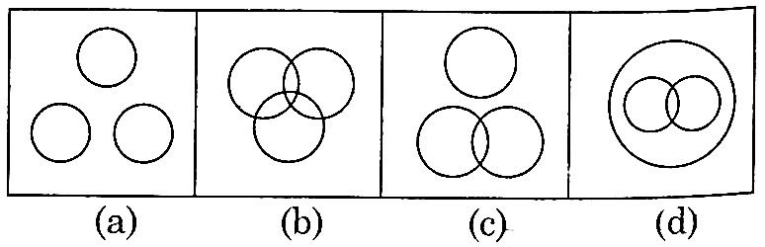
- Which of the following diagram represent roof, door, window?
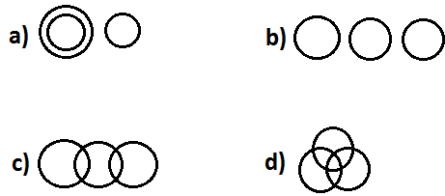
- Which of the following diagrams best depicts the relationship among Sparrows, Birds, Parrots and Bats?
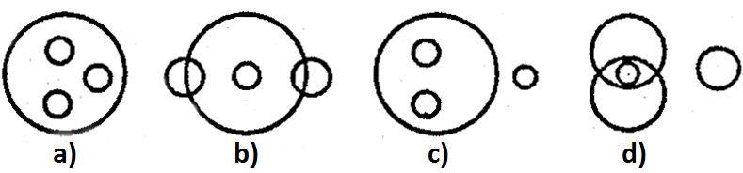

Answer keys:
1 | b | 26 | d
2 | c | 27 | d
3 | d | 28 | c
4 | d | 29 | c
5 | a | 30 | a
6 | d | 31 | c
7 | b | 32 | c
8 | a | 33 | a
9 | e | 34 | b
10 | d | 35 | a
11 | a | 36 | c
12 | a | 37 | a
13 | e | 38 | c
14 | e | 39 | b
15 | b | 40 | d
16 | e | 41 | c
17 | b | 42 | d
18 | c | 43 | b
19 | b | 44 | d
20 | b | 45 | a
21 | a | 46 | a
22 | d | 47 | d
23 | d | 48 | b
24 | a | 49 | b
25 | a | 50 | c

